IGI Global Scientific Publishing Mathematical Equation and Pseudocode Guide
Created: May 14, 2025
Last Edited: May 15, 2025
This guide describes submission criteria for mathematical equations and pseudocode for all IGI Global Scientific Publishing publications.

1. EQUATIONS
In this guide, the term equation(s) will refer to any type of mathematical expression such as equations, expressions, identities, inequalities, functions, etc.

A. Accepted Equation Editing Tools
Equations created with the following editing tools are compatible with IGI Global Scientific Publishing’s content management system:
- Wiris Mathtype math editor (https://www.wiris.com/en/mathtype/), or
- Microsoft Word Equation Tools (preinstalled in most versions of Microsoft Word).
Not Allowed:
- Equations submitted as embedded image files (jpg, png, etc.)
- Equations made using Microsoft Word’s shapes or draw tools (either whole or in-part).
- Equations submitted as LaTeX markup language

B. Inline and Display Equations
Simple math equations can appear within the text as inline equations; however, if an equation is more complex it is best separated from surrounding text and formatted as a display equation.

i. Inline Equations
If an equation has a short length and appears on one line text, it is best formatted as an inline equation.
Extremely simple equations (for example a single variable, or a short equation) can even be typed directly into Microsoft Word without the use of an equation editor. Latin script alphabet variables created in this manner should be italicized to differentiate them from the surrounding text. Any punctuation that would normally follow an inline equation should be included within the equation, so it is not separated when the document is typeset.

Examples (inline equations highlighted):
Where, C_{A}(A) is the cost of authentication level A (higher authentication leads to higher administrative costs), C_{F}(F) is the cost of fraud detection (increasing δ requires more resources, such as sophisticated AI-assisted fraud detection systems), B_{T}(T) is the benefit from correctly …
Note: given their simplicity, the author opted to type all inline equations in the above example directly in Microsoft Word without using an equation editor. The subscript was added through a standard font option.
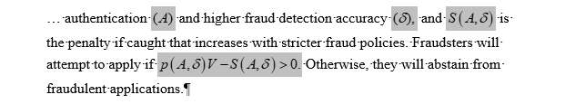
Note: in the above example, all inline equations were written using Mathtype. The punctuation (brackets, commas, end stops, etc.) are all included within the inline equation so they will not be incorrectly separated in later versions of the document.

ii. Display Equations
Equations that have a longer length and/or span multiple lines of text should be arranged as a display equation. Display equations start on a new line to separating them from the preceding text and are labeled with a number in parentheses separated by a tab positioned to the right of the equation. The Display equation label should not be included within the equation file and should not be separated by any other characters (ellipses, dashes, etc.). All display equations should be numbered sequentially throughout the entire document (including any appendices at the end of the document).
Display equations should be written in their entirely using an equation editor. In later versions of the document, display equations will break over multiple lines in unintended ways if they are written in a combination of “regular” text and equation editor files.

Example:
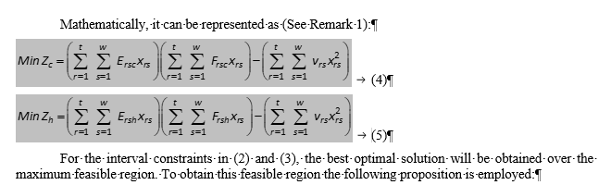
Note: Two complex equations formatted as display equations (written in Mathtype). The labels [(4) and (5)] are separated from the equations by a tab (denoted here by an arrow symbol)
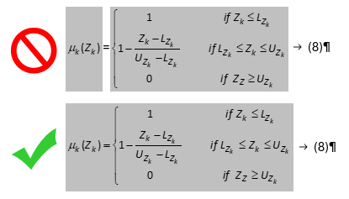
Note: The first display equation above is written as two separate Mathtype files. In later versions of the document it will break into two lines at the equals sign (=), which isn’t what the author intended. The example below is the same display equation correctly written. It will maintain its intended layout in later versions of the document.

C. Fonts
All equations will be subject to processing by our content management system throughout the course of the Production phase. A critical component of this processing involves converting the equations to MathML (a specialized markup language) to be interpreted by later systems in the process. Later templates will automatically interpret the MathML using pre-defined fonts and styling. Because of this, unique fonts for variables should be used sparingly and should be limited to Truetype typefaces. If an incompatible font is used, we will substitute with a similar compatible font to ensure it is readable in the final versions of the document.

2. PSEUDOCODE
Pseudocode should be written using the Courier New Font and indented using tabs as needed. To correctly appear within later versions of the document, pseudocode should never be placed in separate text boxes or tables.

Example:
<XDM:DATA-ITEM Name=“Rules” Version=“1” Virtual=“NO” Date=“...” xmlns:XDM=“http://.../NS/XDM”>
<XDM:DERIVATION Statement=“00128”/>
<XDM:CONTENT>
<AR:ASSOCIATION-RULE-SET
xmlns:AR=“http://...NS/DATA/AssRules”>
<AR:RULE>
<AR:BODY>
<AR:ELEMENT Name=“ITEM”> A </AR:ELEMENT>
<AR:ELEMENT Name=“ITEM”> C </AR:ELEMENT>
</AR:BODY>
<AR:HEAD>
<AR:ELEMENT Name=“ITEM”> B </AR:ELEMENT>
</AR:HEAD>
<AR:SUPPORT value=“0.5”/>
<AR:CONFIDENCE value=“1”/>

