Multilayered Variable Selection in QSPR: A Case Study of Modeling Melting Point of Bromide Ionic Liquids

Supplementary Materials

Table S1. The list of studied bromide ionic liquids (cationic part of 376 ILs shown) with their experimental and predicted (based on the consensus model) melting point [Log (T_{m}°C)] values.
N-alkyl-pyridinium based cation
R1-R5 can be a substituent or H
Compound Nos. | N- substituent | Other substituents |  |  | Exp. m.p. [Log (T_{m}°C)] | Predicted m.p. [Log (T_{m}°C)]
1 | decyl | 3-pentyl |  |  | 1.477 | 1.670
2* | 11-propionylloxyundecyl |  |  |  | 1.544 | 1.740
3 | benzyl | 4-dibenzyl; 3-ethoxycarbonyl |  |  | 1.544 | 1.901
4 | octyl | 4-propyl |  |  | 1.568 | 1.712
5 | tetradecyl | 4-hexyl |  |  | 1.568 | 1.640
6 | tetradecyl | 3-pentyl |  |  | 1.591 | 1.650
7 | decyl | 4-ethoxycarbonyl |  |  | 1.607 | 1.668
8 | dodecyl | 4-propyl |  |  | 1.613 | 1.670
9 | undecyl |  |  |  | 1.622 | 1.708
10* | octyl | 4-ethyl |  |  | 1.628 | 1.748
11* | dodecyl | 4-ethyl |  |  | 1.638 | 1.683
12 | decyl |  |  |  | 1.648 | 1.719
13 | dodecyl |  |  |  | 1.653 | 1.699
14 | hexyl | 2-(2-methyloctyl) |  |  | 1.672 | 1.698
15 | ethoxycarbonylmethyl | 5-butyl; 2-methyl |  |  | 1.708 | 1.861
16 | 2,5- dimethoxyphenethyl |  |  |  | 1.731 | 2.037
17 | tridecyl |  |  |  | 1.736 | 1.691
18 | 4-fluoro-benzyl |  |  |  | 1.760 | 2.068
19 | tetradecyl |  |  |  | 1.771 | 1.683
20* | butyl | 4-ethoxycarbonyl |  |  | 1.778 | 1.884
21 | 2-methylpropyl |  |  |  | 1.806 | 1.959
22 | methyl | 3-(3-hydroxypropyl) |  |  | 1.806 | 2.042
23 | benzyl | 3-methyl |  |  | 1.810 | 2.049
24 | butyl | 2-benzylsulfanyl |  |  | 1.813 | 1.869
25 | 2-cyclohexyl-2-oxo-ethyl |  |  |  | 1.839 | 1.823
26 | methylpropyl |  |  |  | 1.842 | 1.974
27* | 2-pyridinyl |  |  |  | 1.848 | 2.189
28 | 2-(ethoxycarbonyl)ethyl |  |  |  | 1.851 | 1.956
29 | 1-(ethjoxycarbonyl)propyl |  |  |  | 1.863 | 1.938
31* | ethyl | 3-diethylcarbamoyl |  |  | 1.878 | 1.949
32 | 2-phenoxyethyl |  |  |  | 1.886 | 2.010
33 | methyl | 2,4,6-tetramethyl |  |  | 1.892 | 1.993
34 | methyl | 4-(3-hydroxypropyl) |  |  | 1.895 | 2.141
35* | ethyl | 2,6-dimethyl |  |  | 1.898 | 1.962
36 | methyl | 3-pyridinyl |  |  | 1.903 | 2.033
37 | isopropyloxycarbonylmethyl |  |  |  | 1.903 | 2.201
38 | morpholinomethyl | 4-methyl |  |  | 1.903 | 2.026
39 | methyl | 4-benzyl |  |  | 1.916 | 1.916
40 | 2-fluroethyl | 3-ethoxycarbonyl |  |  | 1.932 | 2.081
41 | phenethyl | 4-methyl |  |  | 1.940 | 2.027
42* | butyl | 3-carboxy |  |  | 1.954 | 2.010
43 | allyl | 3-diethylcarbamoyl |  |  | 1.959 | 1.974
44 | bis(ethoxycarbonyl)methyl |  |  |  | 1.964 | 2.040
45 | 4-acetoxybutyl | 3-hydroxy |  |  | 1.971 | 1.987
46* | benzyloxy |  |  |  | 1.978 | 1.953
47 | allyl |  |  |  | 1.978 | 2.008
48 | methyl | 3-methoxycarbonyl |  |  | 1.980 | 2.067
49 | 2-hydroxyethyl | 3-methyl |  |  | 1.982 | 2.070
50* | ethyl | 2-methyl |  |  | 1.987 | 1.987
51 | isopropyl |  |  |  | 1.987 | 2.027
52 | butyl |  |  |  | 1.987 | 2.042
53 | ethyl | 4-(4-pyridyl) |  |  | 1.989 | 1.896
54* | allyl | 3-hydroxy |  |  | 1.991 | 2.114
55 | benzyl |  |  |  | 1.991 | 2.096
56 | methyl | 4-(2-ethoxycarbonylethyl) |  |  | 1.996 | 2.047
57 | ethyl | 3-acetyl |  |  | 1.998 | 1.992
58* | allyl | 3-formyl |  |  | 2.000 | 2.061
59 | acetonyl | 2,6-dimethyl |  |  | 2.000 | 2.096
60 | ethyl | 3-hydroxy |  |  | 2.017 | 2.090
61 | ethoxy | 4-methoxy |  |  | 2.025 | 2.057
62 | propyloxycarbonylmethyl |  |  |  | 2.035 | 2.008
63 | allyl | 2-hydroxymethyl |  |  | 2.041 | 1.949
64 | 2-hydroxyethyl |  |  |  | 2.041 | 2.009
65 | allyl | 4-hydroxymethyl |  |  | 2.041 | 1.979
66 | 5-hexynyl |  |  |  | 2.045 | 2.009
67 | 2-cyanoethyl | 3-methyl |  |  | 2.057 | 1.982
68* | pyridenyl |  |  |  | 2.064 | 2.094
69 | isopropyl | 4-hydroxyethyl |  |  | 2.072 | 2.189
70 | 3-cholropropyl |  |  |  | 2.076 | 1.995
71 | ethyl |  |  |  | 2.079 | 2.075
72* | allyl | 4-cyan |  |  | 2.081 | 2.020
73 | ethyl | 4-methyl |  |  | 2.083 | 2.152
74 | isopropyl | 2-hydroxymethyl |  |  | 2.083 | 2.026
75 | 2-hydroxyethyl | 3-hydroxy |  |  | 2.086 | 1.996
76* | 2-hydroxyethyl | 3,4-dimethyl |  |  | 2.088 | 2.015
77 | 3,3-diethylallyl | 4-methyl |  |  | 2.102 | 1.992
78 | 1-methyl-2-oxopropyl | 2-methyl |  |  | 2.106 | 2.017
79 | 2-cyano-ethyl | 3,4-dimethyl |  |  | 2.124 | 2.099
80* | ethoxycarbonylmethyl |  |  |  | 2.124 | 2.095
81 | 3-bromopropyl | 4-methyl |  |  | 2.137 | 1.999
82 | (Z)-3-methylpent-2-en-4-inyl |  |  |  | 2.145 | 2.010
83 | methyl | 3-methyoxycarbonyl |  |  | 2.145 | 2.126
84* | 2-cyanoethyl | 3-amino |  |  | 2.149 | 2.080
85 | 1-metrhyl-2-oxopropyl |  |  |  | 2.152 | 2.158
86 | cyanomethyl | 3,5-dimethyl |  |  | 2.158 | 2.097
87 | methyl | 4-methyl-3-hydroxy |  |  | 2.158 | 2.148
88* | 2-cyanoethyl | 4-methyl |  |  | 2.164 | 2.176
89 | 2-cyanoethyl |  |  |  | 2.167 | 2.094
90 | methyl |  |  |  | 2.173 | 2.092
91* | methyl | 3-hydroxy |  |  | 2.176 | 2.154
92 | vinyl |  |  |  | 2.186 | 2.184
93 | phenyl |  |  |  | 2.189 | 2.147
94 | (E)-3-hydroxyprop-1-en-1-yl |  |  |  | 2.190 | 2.101
95 | 2-carboxyallyl |  |  |  | 2.195 | 2.026
96* | cyclohex-2-enyl |  |  |  | 2.195 | 2.126
97 | 2-cyanoethyl | 3,5-dimethyl |  |  | 2.203 | 1.886
98 | 3-carboxypropyl |  |  |  | 2.205 | 2.136
99 | methyl | 4-methoxycarbonyl |  |  | 2.212 | 1.998
100 | ethyl | 4-cyano |  |  | 2.215 | 2.080
101 | cyanomethyl |  |  |  | 2.219 | 2.120
102* | methyl | 2-hydroxymethyl |  |  | 2.223 | 2.156
103 | vinyl | 4-methyl |  |  | 2.224 | 2.078
104 | isopropyl | 4-methoxy |  |  | 2.228 | 2.142
105 | methyl | 4-methyl |  |  | 2.229 | 2.068
106* | methoxycarbonylmethyl |  |  |  | 2.238 | 2.148
107 | propyl | 3-carbamoyl |  |  | 2.242 | 2.091
108 | ethyl | 4-dimethylamino |  |  | 2.243 | 2.057
109 | prop-2-ynyl | 4-methyl |  |  | 2.246 | 2.154
110* | cyanomethyl | 4-methyl |  |  | 2.250 | 2.099
111 | 2-fluroethhyl |  |  |  | 2.253 | 2.152
112 | methyl | 4-acetyl |  |  | 2.255 | 2.148
113* | allyl | 4-(hydroxyiminomethyl) |  |  | 2.264 | 2.169
114 | hydrazinocarbonylmethyl |  |  |  | 2.267 | 2.251
115 | 2-oxopropyl |  |  |  | 2.268 | 2.094
116 | ethyl | 4-carbamoyl |  |  | 2.272 | 2.089
117* | (E)-2-carboxy-1-ethenyl | 3-methyl |  |  | 2.274 | 2.061
118 | 2-propionamido |  |  |  | 2.275 | 2.152
119 | (E)-2-carboxy-1-ethenyl | 3-methyl |  |  | 2.278 | 2.152
120 | allyl | 2-(hydroxyiminomethyl) |  |  | 2.280 | 2.149
121 | 2-oxopropyl | 2-methyl |  |  | 2.284 | 2.251
122 | 2-hydroxyethyl | 2-(hydroxyiminomethyl) |  |  | 2.292 | 2.090
123 | cyanomethyl | 2,4-dimethyl |  |  | 2.298 | 2.179
124* | carboxymethyl |  |  |  | 2.299 | 2.150
125 | 2-carbamoylethyl |  |  |  | 2.299 | 2.108
126 | carbamoylmethyl |  |  |  | 2.299 | 2.088
hydroxyalkylammonium cation
Compound Nos. | Cation name |  |  |  | Exp. m.p. [Log (T_{m}°C)] | Predicted m.p. [Log (T_{m}°C)]
127 | (2-hydroxyethyl)-dimethyl-pentyl-ammonium |  |  |  | 1.699 | 2.180
128* | dibutyl-hexadecyl-(2-hydroxyethyl)-ammonium |  |  |  | 1.740 | 1.862
129 | tributyl-(2-hydroxyethyl)-ammonium |  |  |  | 1.763 | 1.948
130* | ethyl-hexadecyl-(2-hydroxyethyl)-methyl-ammonium |  |  |  | 1.806 | 1.927
131 | didodecyl-(2-hydroxyethyl)-methyl-ammonium |  |  |  | 1.813 | 1.889
132 | diethyl-(2-hydroxyethyl)-tetradecyl-ammonium |  |  |  | 1.813 | 1.955
133* | decyl-(3-hydroxypropyl)-dimethyl-ammonium |  |  |  | 1.845 | 2.085
134 | decyl-diethyl-(2-hydroxyethyl)-ammonium |  |  |  | 1.886 | 2.098
135 | hexadecyl-(3-hydroxypropyl)-dimethyl-ammonium |  |  |  | 1.929 | 2.030
136* | (3-hydroxypropyl)-dimethyl-tetradecyl-ammonium |  |  |  | 1.934 | 2.046
137 | didodecyl-ethyl-(2-hydroxyethyl)-ammonium |  |  |  | 2.000 | 1.897
138 | (2-hydroxyethyl)-dimethyl-octyl-ammonium |  |  |  | 2.061 | 2.116
139 | (2-hydroxyethyl)-dimethyl-nonyl-ammonium |  |  |  | 2.079 | 2.100
140 | dodecyl-diethyl-(2-hydroxyethyl)-ammonium |  |  |  | 2.079 | 2.062
141 | diethyl-hexadecyl-(2-hydroxyethyl)-ammonium |  |  |  | 2.114 | 1.944
142 | (2-hydroxyethyl)-methyl-dioctadecyl-ammonium |  |  |  | 2.114 | 1.911
143* | diethyl-(2-hydroxyethyl)-octadecyl-ammonium |  |  |  | 2.134 | 1.934
144 | dihexadecyl-(2-hydroxyethyl)-methyl-ammonium |  |  |  | 2.176 | 1.871
145 | decyl-(2-hydroxyethyl)-dimethyl-ammonium |  |  |  | 2.190 | 2.087
146 | (2-hydroxyethyl)-isopropyl-methyl-propyl-ammonium |  |  |  | 2.190 | 2.214
147 | diethyl-(3-hydroxypropyl)-methyl-ammonium |  |  |  | 2.190 | 2.217
148* | triethyl-(3-hydroxypropyl)-ammonium |  |  |  | 2.217 | 2.171
149 | trimethyl-(3-hydroxypropyl)-ammonium |  |  |  | 2.243 | 2.399
150 | dodecyl-(2-hydroxyethyl)-dimethyl-ammonium |  |  |  | 2.301 | 2.170
151 | (2-hydroxyethyl)-dimethyl-tetradecyl-ammonium |  |  |  | 2.301 | 2.045
152 | (2-hydroxyethyl)-dimethyl-pentadecyl-ammonium |  |  |  | 2.312 | 2.035
153 | (2-hydroxyethyl)-dimethyl-octadecyl-ammonium |  |  |  | 2.322 | 2.016
154 | hexadecyl-(2-hydroxyethyl)-dimethyl-ammonium |  |  |  | 2.352 | 2.028
155 | (2-hydroxyethyl)-diisopropyl-methyl-ammonium |  |  |  | 2.371 | 2.289
156 | triethyl-(2-hydroxyethyl)-ammonium |  |  |  | 2.407 | 2.394
157* | ethyl-(2-hydroxyethyl)-isopropyl-methyl-ammonium |  |  |  | 2.415 | 2.266
158 | (2-hydroxyethyl)-isopropyl-dimethyl-ammonium |  |  |  | 2.439 | 2.307
159 | ethyl-(2-hydroxyethyl)-dimethyl-ammonium |  |  |  | 2.455 | 2.286
160* | (2-hydroxyethyl)-trimethyl-ammonium |  |  |  | 2.477 | 2.394
tetraalkyl-ammonium based cation
Compound Nos. | Cation Name |  |  |  | Exp. m.p. [Log (T_{m}°C)] | Predicted m.p. [Log (T_{m}°C)]
161 | tributyl-(3-methylbutyl)-ammonium |  |  |  | 1.230 | 1.963
162 | butyl-dodecyl-dimethyl-ammonium |  |  |  | 1.602 | 2.074
163 | dimethyl-ditetradecyl-ammonium |  |  |  | 1.699 | 2.009
164 | dibutyl-hexadecyl-methyl-ammonium |  |  |  | 1.708 | 1.969
165* | tributyl-hexyl-ammonium |  |  |  | 1.716 | 1.937
166 | dodecyl-tripropyl-ammonium |  |  |  | 1.748 | 1.957
167 | dimethyl-octadecyl-octyl-ammonium |  |  |  | 1.756 | 2.017
168* | decyl-dimethyl-octadecyl-ammonium |  |  |  | 1.778 | 2.009
169 | dimethyl-octadecyl-tetradecyl-ammonium |  |  |  | 1.792 | 1.995
170 | dodecyl-dimethyl-octadecyl-ammonium |  |  |  | 1.792 | 2.001
171 | triheptyl-propyl-ammonium |  |  |  | 1.813 | 1.965
172 | dihexadecyl-dimethyl-ammonium |  |  |  | 1.813 | 1.995
173 | diethyl-hexadecyl-methyl-ammonium |  |  |  | 1.851 | 2.031
174* | trioctyl-propyl-ammonium |  |  |  | 1.851 | 1.955
175 | tributyl-hexadecyl-ammonium |  |  |  | 1.875 | 1.900
176 | hexadecyl-dimethyl-pentyl-ammonium |  |  |  | 1.881 | 2.041
177* | butyl-hexadecyl-dimethyl-ammonium |  |  |  | 1.919 | 2.043
178 | tetraheptyl-ammonium |  |  |  | 1.954 | 1.947
179* | didocosyl-dimethyl-ammonium |  |  |  | 1.954 | 2.024
180 | tetradodecyl-ammonium |  |  |  | 1.954 | 1.958
181 | tetraoctyl-ammonium |  |  |  | 1.978 | 1.978
182* | dodecyl-diethyl-propyl-ammonium |  |  |  | 1.987 | 2.000
183 | tetrahexyl-ammonium |  |  |  | 2.000 | 1.916
184 | tetrapentyl-ammonium |  |  |  | 2.000 | 1.931
185* | triethyl-hexyl-ammonium |  |  |  | 2.021 | 2.122
186 | triethyl-octyl-ammonium |  |  |  | 2.031 | 2.084
187 | diethyl-methyl-(2,4,4-trimethylpentyl)-ammonium |  |  |  | 2.041 | 2.221
188 | tetrabutyl-ammonium |  |  |  | 2.079 | 1.947
189* | triethyl-heptyl-ammonium |  |  |  | 2.079 | 2.101
190 | tributyl-methyl-ammonium |  |  |  | 2.079 | 2.054
191 | hexadecyl-tripropyl-ammonium |  |  |  | 2.079 | 1.938
192 | ethyl-methyl-bis(3-methylbutyl)-ammonium |  |  |  | 2.104 | 2.125
193* | dodecyl-triethyl-ammonium |  |  |  | 2.114 | 2.034
194 | (2-methylbutyl)-triethyl-ammonium |  |  |  | 2.134 | 2.137
195 | diicosyl-dimethyl-ammonium |  |  |  | 2.137 | 1.978
196 | hexadecyl-dimethyl-octyl-ammonium |  |  |  | 2.164 | 2.024
197* | triethyl-pentyl-ammonium |  |  |  | 2.164 | 2.146
198 | (2-isopropyl-5-methylhexyl)-trimethyl-ammonium |  |  |  | 2.182 | 2.233
199* | hexadecyl-icosyl-dimethyl-ammonium |  |  |  | 2.190 | 1.987
200 | dibutyl-dimethyl-ammonium |  |  |  | 2.220 | 2.195
201* | triethyl-hexadecyl-ammonium |  |  |  | 2.243 | 2.000
202 | triethyl-octadecyl-ammonium |  |  |  | 2.255 | 1.986
203 | trimethyl-pentyl-ammonium |  |  |  | 2.255 | 2.361
204* | heptyl-trimethyl-ammonium |  |  |  | 2.265 | 2.281
205 | hexyl-trimethyl-ammonium |  |  |  | 2.270 | 2.316
206 | dodecyl-ethyl-dimethyl-ammonium |  |  |  | 2.274 | 2.110
207* | ethyl-hexadecyl-dimethyl-ammonium |  |  |  | 2.279 | 2.071
208 | butyl-trimethyl-ammonium |  |  |  | 2.290 | 2.406
209 | (3-methylbutyl)-trimethyl-ammonium |  |  |  | 2.301 | 2.354
210* | (1-isopropyl-3-methylbutyl)-trimethyl-ammonium |  |  |  | 2.307 | 2.337
211 | trimethyl-(4-methylpentyl)-ammonium |  |  |  | 2.322 | 2.366
212 | butyl-triethyl-ammonium |  |  |  | 2.322 | 2.168
213 | (1-methylheptyl)-trimethyl-ammonium |  |  |  | 2.322 | 2.288
214* | trimethyl-octyl-ammonium |  |  |  | 2.332 | 2.250
215 | (2-methylbutyl)-trimethyl-ammonium |  |  |  | 2.352 | 2.399
216 | (2-ethyldecyl)-trimethyl-ammonium |  |  |  | 2.354 | 2.156
217 | trimethyl-nonyl-ammonium |  |  |  | 2.362 | 2.225
218 | trimethyl-propyl-ammonium |  |  |  | 2.380 | 2.629
219 | decyl-trimethyl-ammonium |  |  |  | 2.380 | 2.204
220* | trimethyl-(1-butylpentyl)-ammonium |  |  |  | 2.380 | 2.217
221 | (1-ethylpropyl)-trimethyl-ammonium |  |  |  | 2.389 | 2.554
222 | trimethyl-octadecyl-ammonium |  |  |  | 2.398 | 2.103
223 | dodecyl-trimethyl-ammonium |  |  |  | 2.398 | 2.170
224* | hexadecyl-trimethyl-ammonium |  |  |  | 2.398 | 2.120
225 | trimethyl-tetradecyl-ammonium |  |  |  | 2.398 | 2.142
226 | ethyl-diisopropyl-methyl-ammonium |  |  |  | 2.398 | 2.417
227 | triethyl-isopropyl-ammonium |  |  |  | 2.422 | 2.364
228 | tetraethyl-ammonium |  |  |  | 2.431 | 2.384
229* | diethyl-isopropyl-methyl-ammonium |  |  |  | 2.442 | 2.439
230 | tetrapropyl-ammonium |  |  |  | 2.447 | 2.061
231 | (3,3-dimethylbutyl)-trimethyl-ammonium |  |  |  | 2.458 | 2.341
232 | triethyl-methyl-ammonium |  |  |  | 2.477 | 2.477
233 | diethyl-dimethyl-ammonium |  |  |  | 2.505 | 2.589
234 | isopropyl-trimethyl-ammonium |  |  |  | 2.505 | 2.450
235* | ethyl-trimethyl-ammonium |  |  |  | 2.519 | 2.435
Imidazolium cation
Compound Nos. | 1-substituent | 3-substituent | other substituents | Exp. m.p. [Log (T_{m}°C)] | Predicted m.p. [Log (T_{m}°C)]
236 | -CH₃ | -CH₂COPh |  |  | 1.690 | 2.167
237* | -CH₃ | -C₂H₅ |  |  | 1.812 | 2.122
238* | -CH=CH₂ | n-C₄H₉ |  |  | 1.919 | 2.031
239 | n-C₁₀H₂₁ | -CH₃ | 2-CH₃ |  | 1.927 | 1.974
240 | -CH₃ | -CH₂COC₆H₄(m-OC₃H₇) |  |  | 1.929 | 2.111
241 | -CH₂CH=CH₂ | -CH₂CHCN |  |  | 1.947 | 2.114
242 | -CH₃ | -CH₂C₆H₄(p-COPh) |  |  | 1.971 | 2.157
243 | -CH₃ | -CH₂CH₂OH |  |  | 1.988 | 2.081
244 | -CH=CH₂ | -C₂H₅ |  |  | 1.998 | 2.151
245* | -CH₃ | -CH₃ |  |  | 2.039 | 2.258
246* | -CH₃ | n-C₄H₉ | 5-CH₃ |  | 2.043 | 2.013
247 | -CH₃ | -CH₂C₆H₄(m-CH₃) |  |  | 2.061 | 2.146
248* | -CH₃ | -CH₂C₆H₄(o-CH₃) |  |  | 2.061 | 2.146
249 | -CH₃ | -CH₂COPh |  |  | 2.068 | 2.167
250 | -CH₃ | -CH₂Ph |  |  | 2.100 | 2.145
251 | -CH₃ | -CH₂COC₆H₄(m-OC₂H₅) |  |  | 2.138 | 2.146
252 | -CH₃ | -C(CH₃)₂COPh |  |  | 2.141 | 2.182
253 | -CH₃ | -CH₂COC₆H₄(p-OC₂H₅) |  |  | 2.160 | 2.105
254 |  |  |  |  | 2.167 | 2.166
255 | -CH₃ | -CH₂COC₆H₄(p-Cl) |  |  | 2.172 | 2.162
256 | n-C₃H₇ | -CH₂COPh |  |  | 2.173 | 2.054
257 | -CH₃ | -CH₂COC₆H₄(o-CH₃) |  |  | 2.185 | 2.208
258 | -C₂H₅ | -C₂H₅ | 4-Ph,5-Ph |  | 2.186 | 2.064
259* | -CH=CH₂ | n-C₃H₇ |  |  | 2.190 | 2.083
260 | -CH₃ | -CH₂COC₆H₄ | (p-OMe) |  | 2.197 | 2.177
261 | n-C₃H₇ | n-C₃H₇ | 2-CH₂CH(CH₃)₂ |  | 2.211 | 2.006
262 | -CH₃ | -CH₂COC₆H₃[3,4(-CH₃)₂] |  |  | 2.215 | 2.234
263 | -CH₃ | -CH₂COC₆H₄(o-OCH₃) |  |  | 2.220 | 2.177
264 | -CH₃ | -CH₂COC₆H₄(m-Cl) |  |  | 2.246 | 2.189
265* | -CH(CH₃)₂ | -CH₂COC₆H₄(m-OCH₃) |  |  | 2.250 | 2.173
266 | -CH₃ | -CH₂COC₆H₄(o-F) |  |  | 2.253 | 2.185
267* | -CH₃ | -CH₂COC₆H₃[3,4-(Cl)₂] |  |  | 2.264 | 2.207
268 | -CH₃ | -CH₂COPh | 2-CH(=CH₂)Ph |  | 2.267 | 2.366
269 | -CH₃ | -(CH₂)2C₆H₄(p-NO₂) |  |  | 2.267 | 2.187
270* | -CH₃ | -CH₂Ph | 2-n-C₇H₁₅ |  | 2.271 | 2.123
271 | CH₃ | -CH₂COC₆H₄(p-NO₂) |  |  | 2.273 | 2.238
272* | -CH₃ | -CH₃ | 5-Cl |  | 2.291 | 2.291
273* | -CH₃ | -CH₂COPh | 2-CH(=CH₂)C(CH₃)₃ |  | 2.301 | 2.253
274 | -CH₃ | -CH₂COC₆H₄(p-Cl) | 2-CH₃ |  | 2.303 | 2.323
275 | -CH₃ | -CH₂COC₆H₃[2,5-(OCH₃)₂] |  |  | 2.319 | 2.225
276 | -CH₃ | -CH₂COC₆H₄(p-CN) |  |  | 2.326 | 2.298
277 | -CH₃ | -CH₂COC₆H₃[2,3(-OCH₃)₂] |  |  | 2.334 | 2.225
278* | -CH₃ | -CH₂COC₆H₄(p-Br) |  |  | 2.339 | 2.190
279 | -CH₃ | -CH₂COC₆H₂[2,4,6-(CH₃)₃] |  |  | 2.347 | 2.290
280 | -CH₃ | -CH₂C₆H₄[2-COOC₆H₄(p-NO₂)] | 2-CH₃ |  | 2.349 | 2.346
281 |  |  |  |  | 2.363 | 2.347
282 | -CH₃ | -CH₂COC₆H₃[3,4-(OCH₃)₂] |  |  | 2.365 | 2.225
283 |  |  |  |  | 2.377 | 2.347
284* | -CH₃ | -CH₂COC₆H₃[3,5-(OCH₃)₂] |  |  | 2.380 | 2.266
285* | -CH₃ | -CH₂COC₆H₄(p-Ph) |  |  | 2.395 | 2.197
286 | -CH₃ | -CH₃ | 2-Br,4-Br,5-Br |  | 2.428 | 2.340
287* | -CH₃ | -CH₃ | 2-Ph |  | 2.452 | 2.344
288 | -OCH₂C₆H₃[2,4(Cl)₂] | -CH₂COC₆H₄(p-Cl) |  |  | 2.021 | 2.212
289 | -OH | -CH₂C₆H₃[2,4-(Cl)₂] |  |  | 2.061 | 2.176
290* | -OCH=CH₂ | -CH₂C₆H₃[2,4(Cl)₂) |  |  | 2.068 | 2.180
291* | -OC₂H₅ | -CH₂C₆H₄(p-NO₂) |  |  | 2.079 | 2.166
292 | -OC₂H₅ | -CH₂COC₆H₄(p-Cl) |  |  | 2.114 | 2.092
293 | -OC₂H₅ | -CH₂C₆H₃[2,4-(Cl)₂] |  |  | 2.127 | 2.092
294 |  |  |  |  | 2.137 | 2.155
295* | -OCH₂CH₂Ph | -CH₂C₆H₃[2,5-(Cl)₂] |  |  | 2.140 | 2.160
296 | -OCOC(CH₃) | -CH₂COC₆H₄(p-Cl) |  |  | 2.146 | 2.134
297 | -OPh | -CH₂COC₆H₄(p-N(CH₃)₂) |  |  | 2.149 | 2.245
298* | -OCH₂Ph | -CH₂C₆H₃[2,4-(Cl)₂] |  |  | 2.158 | 2.144
299 | -OH | -OH | 2-Br,4-CH₃,5-CH₃ |  | 2.182 | 2.226
300 | -OH | -OH | 2-CH₃,4-Br |  | 2.188 | 2.368
301 | -OCH₂C₆H₃(2,6[Cl]₂) | -OCH₂C₆H₃(2,6[Cl₂]) | 2-C₂H₅ |  | 2.193 | 2.276
302 | -OCH₃ | -CH₂COC₆H₄(p-Cl) |  |  | 2.193 | 2.162
303 | -OH | -OH | 2-Ph,4-Br |  | 2.199 | 2.321
304* | -OCH₂Ph | -CH₂C₆H₂[3,4,5(-OCH₃)₃] | 2-C₂H₅ |  | 2.201 | 2.283
305 | -OCOCH(CH₃)₃ | -CH₂COC₆H₄(p-Cl) |  |  | 2.220 | 2.134
306* | -OCH2C₆H₄(p-NO₂) | -OCH₂C₆H₄(p-NO₂) | 2-CH₃ |  | 2.225 | 2.380
307 | -OCH2C₆H₄(p-Br) | -OCH₂C₆H₄(p-Br) | 2-C₂H₅ |  | 2.230 | 2.249
308 | -OPh | -CH₂COC₆H₄(p-Cl) | 2-C₂H₅ |  | 2.233 | 2.292
309 | -OCH2C₆H₄(p-Br) | -OCH₂C₆H₄(p-Br) | 2-CH₃ |  | 2.241 | 2.282
310 | -OCH₂C₆H₃(2,4[Cl]₂) | -OCH₂C₆H₃(2,4-[Cl]₂) | 2-C₂H₅ |  | 2.246 | 2.276
311 | -OH | -OH | 2-Br |  | 2.258 | 2.249
312 | -OCOC(CH₃)₃ | -CH₂COC₆H₄(p-Cl) | 2-C₂H₅ |  | 2.265 | 2.234
313 | -OH | -CH₂C₆H₂[3,4,5(-OCH₃)₃] |  |  | 2.279 | 2.159
314 | -OH | -CH₂COC₆H₄(p-Cl) | 2-C₂H₅ |  | 2.299 | 2.257
315 | -OH | -CH₂COC₆H₄(p-Cl) | 2-CH₃ |  | 2.301 | 2.306
316 | -OH | -CH₂COC₆H₄(p-Cl) |  |  | 2.305 | 2.172
317 | -CH₂Ph | -CH₂Ph |  |  | 1.796 | 2.088
318 | -CH₂Ph | n-C₁₀H₂₁ | 2-CH₃ |  | 1.942 | 2.040
319* | -CH₂Ph | n-C₁₄H₂₉ | 2-CH₃ |  | 2.013 | 1.984
320 | -CH₂Ph | n-C₅H₁₁ | 2-n-C₁₁H₂₃ |  | 2.066 | 2.006
321 | -CH₂Ph | -CH₂Ph | 4-C₂H₄OH |  | 2.130 | 2.024
322* | -Ph | -CH₂COC₆H₄(m-OCH₃) |  |  | 2.167 | 2.201
323 | -CH₂Ph | -CH₃ | 2-n-C₁₁H₂₃ |  | 2.271 | 2.052
324 | -CH₂CH₂Ph | -CH₂COC₆H₄(p-Br) | 2-CH₃ |  | 2.286 | 2.318
325* | -CH₂Ph | -CH₂COC₆H₄(p-OCH₃) | 2-CH₃ |  | 2.305 | 2.292
326 | -Ph | -CH₂COC₆H₄(p-CH₃) | 2-CH₃ |  | 2.313 | 2.329
327* | -C(Ph)₃ | -CH₂COPh | 4-CH₃ |  | 2.313 | 2.258
328* | -CH₂Ph(p-OCH₃) | -CH₂COC₆H₄(p-CH₃) | 2-CH₃ |  | 2.351 | 2.375
329 | -CH₂Ph | -CH₂COC₆H₄(p-Cl) | 2-CH₃ |  | 2.359 | 2.300
330 | -CH₂Ph | -CH₂COPh | 2-CH₃ |  | 2.378 | 2.283
331 | -Ph | -Ph | 2-Ph,4-NH₂ |  | 2.428 | 2.340
332 | -Ph | -CH₃ | 2-Ph,4-NH₂ |  | 2.452 | 2.344
benzimidazolium cation
Compound Nos. | 1-substituent | 3-substituent | Other substituents |  | Exp. m.p. [Log (T_{m}°C)] | Predicted m.p. [Log (T_{m}°C)]
333* | -(CH₂)₃CN | -(CH₂)₂CN |  |  | 2.178 | 2.377
334* | -CH₃ | -CH₂CH=CH₂ |  |  | 2.212 | 2.315
335 | -CH₂COOH | -CH₂COPh |  |  | 2.244 | 2.239
336 | -CH₂OH | -CH₂COPh |  |  | 2.262 | 2.249
337 | -CH₃ | -CH₂COPh | 5-OCH₃ |  | 2.292 | 2.274
338* | -C₂H₅ | -CH₂COC₆H₄(p-Br) |  |  | 2.297 | 2.220
339 | -CH₂COOCH₃ | -CH₂COPh | 2-CH₃ |  | 2.312 | 2.368
340 | -C₂H₅ | -C₂H₅ |  |  | 2.314 | 2.200
341 | -CH(CH₃)₂ | -CH₂COPh | 2-NH₂ |  | 2.318 | 2.342
342* | -CH₂COOCH₃ | -CH₂COC₆H₄(p-Br) | 2-CH₃ |  | 2.324 | 2.384
343 | -CH₂COOCH₃ | -CH₂COC₆H₄(p-OCH₃) | 2-CH₃ |  | 2.331 | 2.375
344 | -CH₂CH=CH₂ | -CH₂COC6H4(p-Br) |  |  | 2.332 | 2.239
345* | -CH₂COOC₂H₅ | -CH₂COPh | 2-C₂H₅ |  | 2.332 | 2.320
346 | -CH₃ | -CH₂COOC₂H₅ | 2-CH₃ |  | 2.332 | 2.397
347 | -CH₂COOCH₃ | -CH₂COC₆H₄(p-CH₃) | 2-CH₃ |  | 2.336 | 2.410
348 | -CH₃ | -CH₂COPh | 5-NO₂ |  | 2.349 | 2.368
349 | -Ph | -CH₂COC₆H₄(p-NO₂) | 2-CH₃ |  | 2.355 | 2.416
350* | -C₄H₉ | -CH₂COOCH₃ | 2-NH₂ |  | 2.357 | 2.228
351* | -(CH₂)₃COOC₂H₅ | -CH₂Ph | 2-CH₃ |  | 2.364 | 2.248
352 | -CH₂COOCH₃ | -CH₂COCH₃ | 2-CH₃ |  | 2.364 | 2.432
353 | -C₂H₅ | -CH₂COOC₂H₅ | 2-C₂H₅ |  | 2.367 | 2.288
354* | -CH₂COOCH3 | -CH₃ | 2-CH₃ |  | 2.369 | 2.472
355 | -CH₂COOC₂H₅ | -CH₂COPh | 2-C₂H₅ |  | 2.370 | 2.320
356* | -(CH₂)₃COOH | -CH₂Ph | 2-CH₃ |  | 2.371 | 2.307
357 | -CH₃ | -CH₂COC₆H₄(p-NO₂) | 5-NO₂ |  | 2.372 | 2.420
358 | -C₂H₅ | -C₂H₅ | 2-CH₃ |  | 2.374 | 2.343
359* | n-C₁₅H₃₁ | n-C₁₅H₃₁ | 2-CH₃ |  | 2.377 | 2.060
360 | -CH₃ | -CH₂COC₆H₄(p-NO₂) | 5-OCH₃ |  | 2.378 | 2.331
361 | -CH₃ | -CH₂COOCH₃ | 2-NH₂ |  | 2.381 | 2.372
362 | -CH₃ | -CH₂CN | 2-CH₃ |  | 2.384 | 2.504
363 | n-C₉H₁₉ | n-C₉H₁₉ | 2-CH₃ |  | 2.391 | 2.142
364 | -CH₂Ph | -CH₂COC₆H₄(p-NO₂) | 2-CH₃ |  | 2.394 | 2.415
365 | -CH₂COOC₂H₅ | -CH₂COOC₂H₅ | 2-CH₃ |  | 2.397 | 2.310
366 | -CH₃ | -CH₂COOC₂H₅ | 2-NH₂ |  | 2.401 | 2.298
367 | -C₂H₅ | -CH₂COC₆H₄(p-NO₂) | 5-CH₃,6-CH₃ |  | 2.404 | 2.265
368* | -CH₃ | -CH(CH₃)COOCH₃ | 2-CH₃ |  | 2.407 | 2.485
369 | -NH₂ | -CH₂COPh | 2-NH₂ |  | 2.411 | 2.434
370 | -C₂H₅ | -CH₂CN | 2-CH₃ |  | 2.417 | 2.423
371 | -CH₃ | -CH₂COPh | 2-CH₃,5-NO₂ |  | 2.422 | 2.502
372* | -CH₃ | -CH₃ | 2-C₂H₅,5-NO₂ |  | 2.423 | 2.533
373 | -CH₃ | -CH₃ | 5-Cl |  | 2.439 | 2.406
374* | -NH₂ | -CH₂COC₆H₄(p-OCH₃) | 2-NH₂ |  | 2.446 | 2.441
375 |  |  |  |  | 2.504 | 2.479
376 | -CH₂C₆H₄(p-NO₂) | -CH₂C₆H₄(p-NO₂) | 2-NH₂ |  | 2.568 | 2.552

* indicates test set compounds

Table S2. Relative importance of descriptors based on VIP plot.
Final PLS models
Model Nos. | Model-1 | Model-2 | Model-3 | Model-4 | Model-5
Relative importance of Descriptors | F01[C-N] | F01[C-N] | <5-F01[C-N]> | F01[C-N] | <5-F01[C-N]>
 | ETA_Shape_P | ETA_Shape_P | ETA_Shape_P | ETA_Shape_P | ETA_Shape_P
 | ETA_EtaP_L | ETA_EtaP_L | ETA_EtaP_L | ETA_EtaP_L | ETA_EtaP_L
 | C-043 | C-043 | C-043 | C-043 | C-043
 | <F07[C-N]-2> | <F07[C-N]-2> | <F07[C-N]-2> | <F07[C-N]-2> | <F07[C-N]-2>
 | NNRS | NNRS | NNRS | NNRS | NNRS
 | C-006 | C-006 | C-006 | C-006 | C-006
 | <X4Av-0.111> | <X4Av-0.111> | <X4Av-0.111> | <X4Av-0.111> | <X4Av-0.111>
 | nArCOOR | nCH₂RX | nCH₂RX | nCH₂RX | nCH₂RX
 | nArCNO | nArCOOR | nArCOOR | nArCNO | nArCNO

Table S3. The quality of the consensus model obtained according to Golbraikh and Tropsha criteria.
 | Parameters | Consensus model | Remarks | Threshold value
1 | r^2 | 0.615 | Passed | r^2>0.6
2 | [(r^2-r0^2)/r^2] | 0.000113 | Passed | <0.1
 | [(r^2-r0^'2)/r^2] | 0.411 | Failed
3 | k | 1.0007 | Passed | 0.85<k or k'<1.15
 | k' | 0.996

Figure S1. Y-scrambling of the PLS model (model 1) based on 100 randomization cycles.

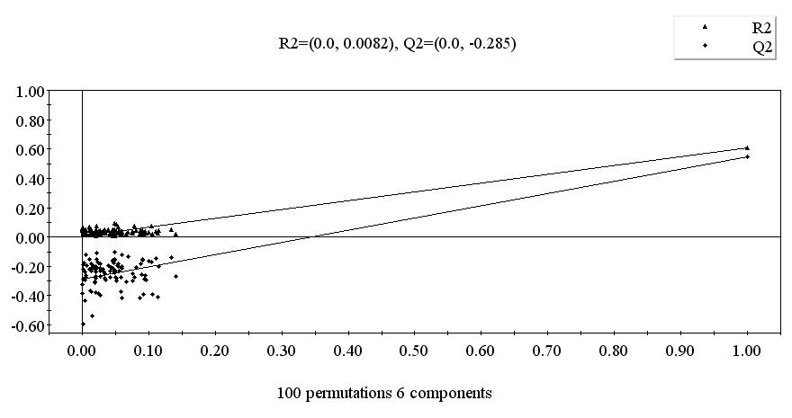
Figure S2. Y-scrambling of the PLS model (model 2) based on 100 randomization cycles.

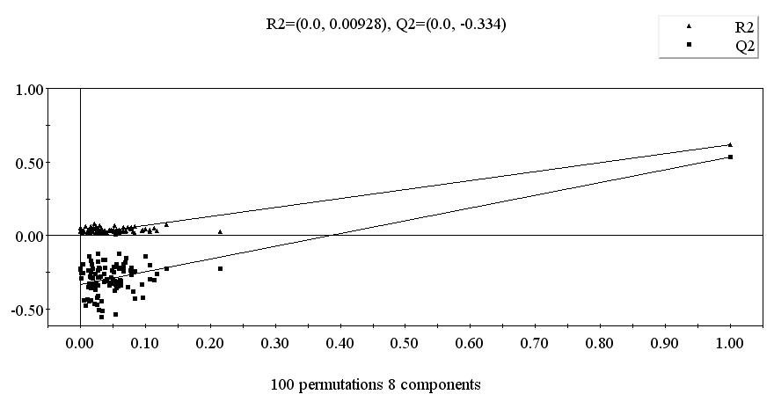

Figure S3. Y-scrambling of the PLS model (model 3) based on 100 randomization cycles.

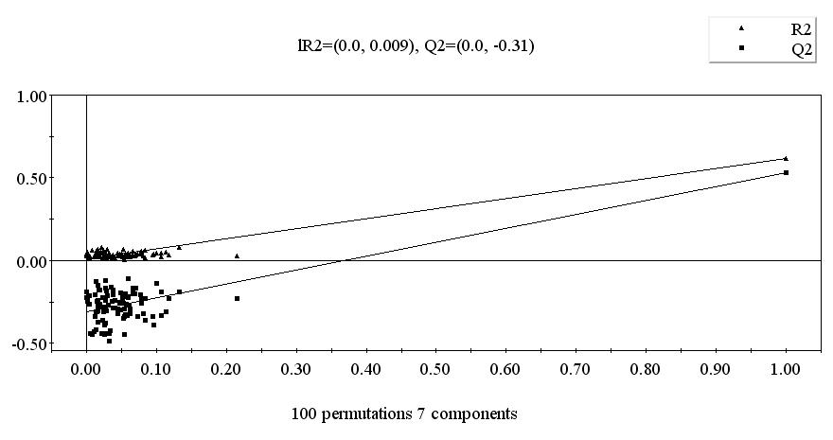

Figure S4. Y-scrambling of the PLS model (model 4) based on 100 randomization cycles.

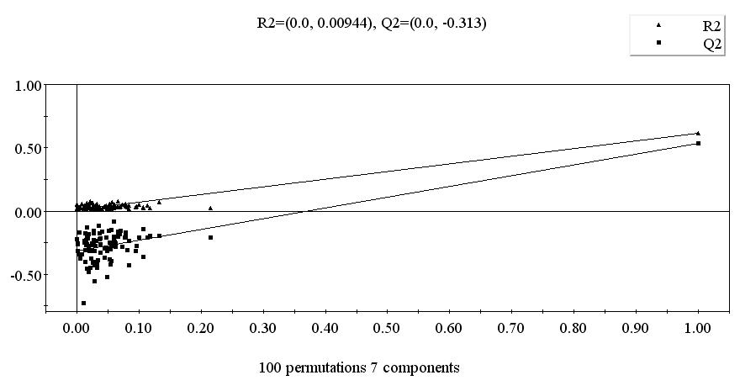

Figure S5. Y-scrambling of the PLS model (model 5) based on 100 randomization cycles.

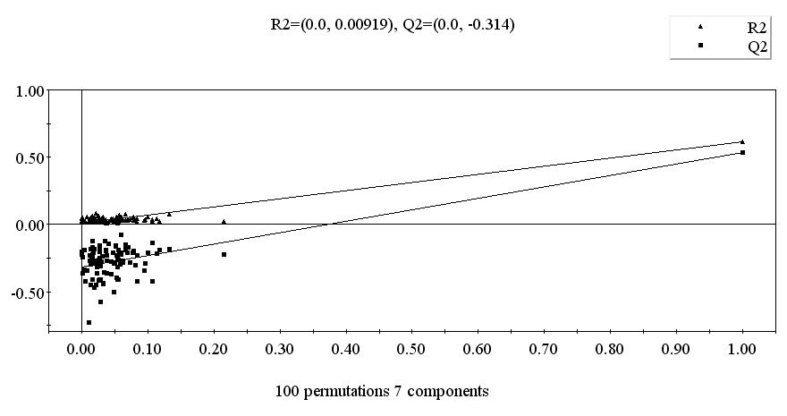

Figure S6. Variable importance plot (VIP) of model 1.

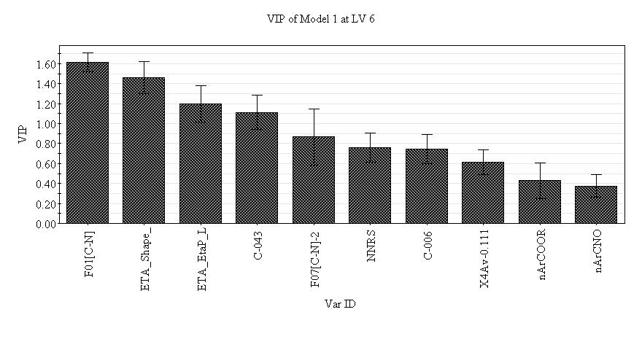

Figure S7. Variable importance plot (VIP) of model 2.

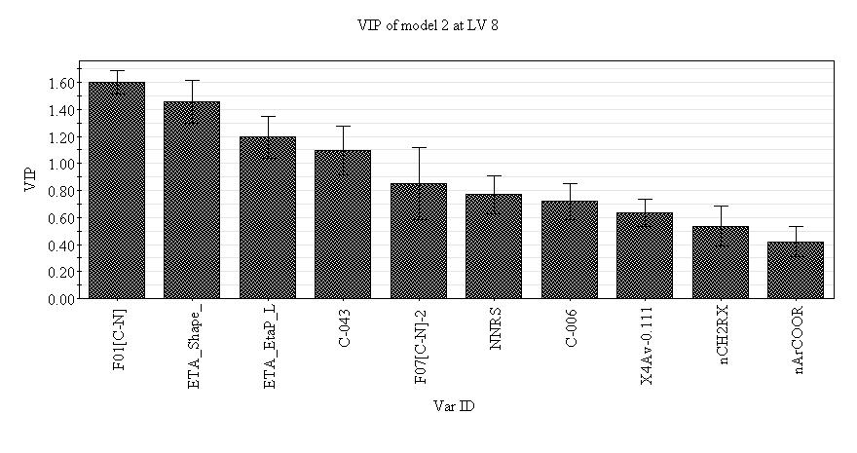

Figure S8. Variable importance plot (VIP) of model 3.

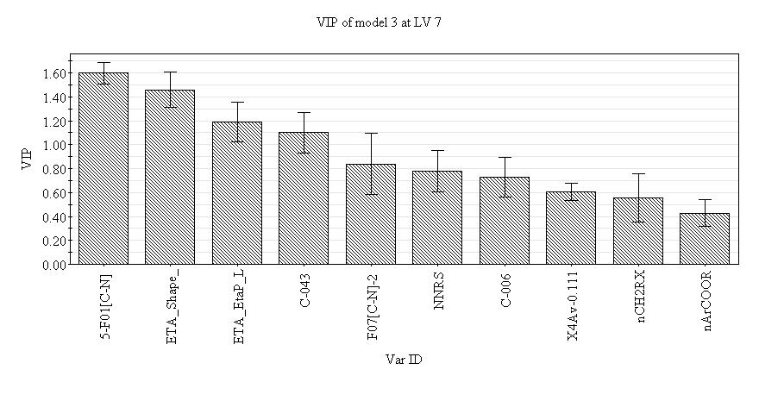

Figure S9. Variable importance plot (VIP) of model 4.

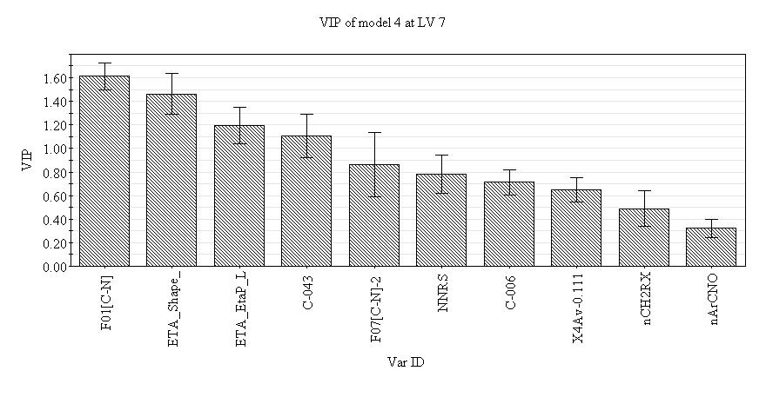

Figure S10. Variable importance plot (VIP) of model 5.
