**Supplemental Materials Online**

**Part I**

**Detailed Review of the Evidence for the Predictions**

As stated in the introduction, the interpretation of the meaning of AU patterns has been approached differently from the perspectives of discrete emotion theories and componential theories. Discrete emotion theorists derived specific AU patterns from prototypical facial expressions of basic emotions, whereas the componential approach explains them by referring to their adaptive function in terms of information processing, action tendencies, or communicative signals. The latter, more analytical approach, suggests that individual AUs may carry information specific to particular appraisal dimensions and that AU combinations reflect more complex appraisal configurations. Our results can help to determine the plausibility of this account. The results reported above are discussed both factually and with respect to how well they match the CPM predictions shown in Table 1 of the article.

The evidence reported in the article is detailed below for each appraisal dimension. In terms of weighing the evidence resulting from the various analyses, more importance is given to the output of the regression analysis, which, as previously noted, has the advantage of taking into account other significant AUs simultaneously. Additional support for the role of specific AUs as elements of an appraisal response comes from the ANOVA data, which showed the relative contribution of single AUs to combinations in predicting the rated appraisal dimension.

**Novelty.** In line with CPM predictions, perceived novelty was strongly linked to the action of eyes (AU5) and mouth (AU26, AU27) opening. The presence of brow raisers as AU2 was detected only in the regression model of the other two levels of intensity. These results match those extracted from the *t* tests. To a lesser extent, AU20 (Lip Stretcher) and AU43 (Eyes Closed) also seemed to predict perceived novelty. This was compatible with CPM predictions: AU17 (Chin Raiser) and AU24 (Lip Pressor) could be considered as part of a broad novelty response, including the additional meaning of low coping potential as lack of control in a situation, but is not a specific signal of pure novelty (i.e., without valence). The evidence for an association between AU1 (Inner Brow Raiser) and AU2 (Outer Brow Raiser) and novelty was less strong (AU2 did not appear the regression model only for 60% intensity and AU1 was absent from the regression model across all intensities). This might imply that the strongest signal of novelty does not require the presence of inner eyebrow raise. However, the fact that average ratings of AU1+2+5+26 and AU27 for novelty were still the highest suggests that AU1+2 contributes to perceived novelty to some extent.

**Unpredictability.** The best predictors of perceived unpredictability were AU2, AU27, AU26, AU7, AU5, and AU23. In particular, AU2 (Outer Brow Raised), AU27 (Mouth Stretch), AU26 (Jaw Drop), AU7 (Lid Tightener), and AU5 (Upper Lid Raised) were consistent with CPM predictions in the broader sense, as part of a general novelty/unpredictability response. AU4 (Brow Lowerer) was not included in the regression model for the 60% intensity or other levels. In addition, AU1 was included in the regression model for the 90% intensity ratings, suggesting that its signal value for unpredictability might be higher at an increased intensity. The *t* tests showed the same pattern of results and again the possible presence of AU23 (Lip Tightener) and AU25 (Lips Part) as AU43, which could be considered as part of a broader response, including the additional meaning of low coping potential and obstructiveness of one’s own goals. However, the fact that unexpectedness average ratings of AU1+2+5+26 and AU27 were still the highest suggests that raters have difficulties in discriminating novelty and unpredictability appraisals.

**Intrinsic pleasantness.**The AUs predicted by the CPM as specific elements of the pleasantness response were among the best predictors for this dimension: AU6 (Cheek Raiser) and AU9 (Nose Wrinkler). Remarkably, very different AUs were included in the regression model for 30% and 90% intensity levels, confirming that the valenced effect of pleasantness was not easy to rate, especially for subtle expressions such as those at lower intensity. The data derived from *t* testssupport these statements and include the detection of AU15 (Lip Corner Depressor) and AU43, thus involving configurations that invoke a movement of the lips as important cues for the perception of pleasantness. AU12+43 and AU6+12+25 received the highest ratings, albeit shown at the lower intensity rate, confirming the importance of AU6 and AU12 (Lip Corner Puller) for pleasantness perception. Unpleasantness instead seemed to be more related to combinations, including AU9, AU10 (Upper Lip Raiser), AU15, and AU17 across all levels of intensity, as predicted by the CPM.

**Congruency with expectations.** The presence of AU2 is consistent with CPM general predictions, which included elements of the novelty responses in the appraisal of expectations. In addition, AU26 was present in the regression model at the 30% and 60% intensity levels. The expected AUs 4 and 7, predicted as a specific combination to signal a discrepancy with one’s own expectations, are not included in the model as in the *t* tests, but they receive low ratings according to CPM predictions.

**Goal conduciveness.**In line with the CPM, AU6 was present as AUs associated with goal conduciveness, which include elements of the pleasantness response (AU6) and additional AUs (AU2, AU23, AU26, AU27) for the other intensities, more specifically, those linked to goal obstruction and low coping. Contrary to predictions, AU24 (Lip Pressor) was not included in the model. These results are replicated by the ANOVA; the average ratings showed a congruent position for the stimuli predicted to be perceived as goal conducive, whereas there was a larger spread according to the goal obstructive ratings, which seemed to be related to the presence of AU10, AU26, and AU25, but not with a specific trend.

**Coping potential.**As part of the low/no coping potential/control response, AU27 and AU26 were strongly predicted by the CPM. AU4 is not included in the specific predictions, but can be part of the response associated with no control and high control, according to which other AUs are present. The role of AU9 and AU43 was more difficult to interpret. The regression model for the other intensities also includes AU1 and AU2, suggesting that the perception of something as novel or unpredictable tends to also elicit a perception of relatively low coping potential. Average ratings showed a pattern of response for high coping potential as being more similar to the pleasantness and conduciveness pattern, including combinations that showed AU6, AU12, and AU25, while all the other ratings seemed to have a larger spread and were not really specific for a particular set of configurations.

**Self/other-norm compatibility.** One might expect that it would be difficult to make a conscious perceptual distinction between compatibility with self-norms versus other norms. Indeed, the results obtained were mixed for these two appraisals. Overall, AU10, specifically predicted for other-norm compatibility, was absent. In contrast, AU43 was among the predictors for self- and other-norm compatibility for intensities 60% and 90%. All other AUs included in the model were consistent with general CPM predictions, to the extent that the response to norm violations includes elements of the unpleasantness (AU43, AU9, and AU16) and coping potential (AU27, AU26, and AU5) response. The regression model for the 90% intensity ratings further supported the role of mouth opening (AU26 and AU27) as a signal of attributed norm violations. Furthermore, both *t* tests and average analyses confirmed the difficulty in precisely discriminating these two appraisal categories and emphasized the tendency of the raters to associate such appraisals to valence more than to the appraisal itself.

**Part II**

**Tables and Figures**

Table S1

*CPM General Predictions*

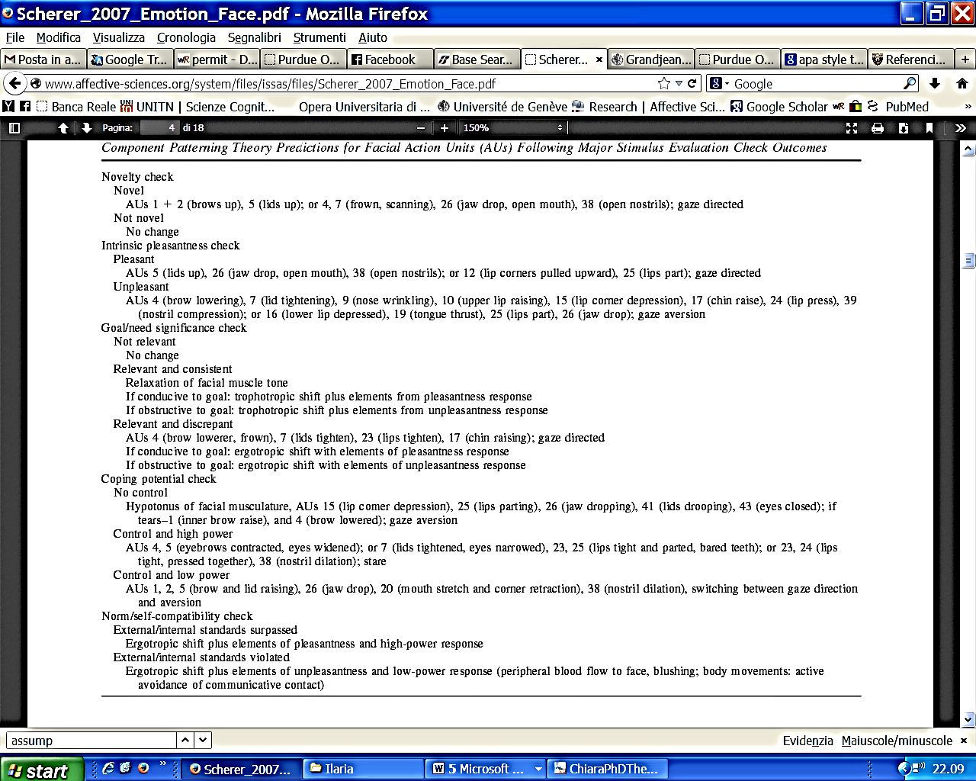

*Note.* AU = action unit; CPM = Component Process Model. Reprinted with permission from Scherer and Ellgring, 2007, p. 116.

Table S2

*Reliability Coefficients per Intensity and Appraisal Dimension* a

|  |  |
| --- | --- |
| Domain/Appraisal scale | ICC (95% CI) |
| All intensities | 0.95 [0.94, 0.95] |
| Intensity 30% | 0.90 [0.88, 0.91] |
| Novelty | 0.79 [0.68, 0.87] |
| Unpredictability | 0.75 [0.62, 0.85] |
| Intrinsic pleasantness | 0.95 [0.92, 0.97] |
| Congruency with expectations | 0.93 [0.89, 0.96] |
| Goal conduciveness | 0.93 [0.90, 0.96] |
| Coping potential | 0.86 [0.81, 0.92] |
| Self-norm compatibility | 0.94 [0.91, 0.96] |
| Other-norm compatibility | 0.93 [0.90, 0.96] |
| Intensity 60% | 0.95 [0.94, 0.96] |
| Novelty | 0.81 [0.71, 0.89] |
| Unpredictability | 0.78 [0.67, 0.87] |
| Intrinsic pleasantness | 0.97 [0.95, 0.98] |
| Congruency with expectations | 0.97 [0.95, 0.98] |
| Goal conduciveness | 0.95 [0.93, 0.97] |
| Coping potential | 0.94 [0.91, 0.96] |
| Self-norm compatibility | 0.96 [0.94, 0.98] |
| Other-norm compatibility | 0.96 [0.94, 0.98] |
| Intensity 90% | 0.96 [0.95, 0.97] |
| Novelty | 0.83 [0.74, 0.90] |
| Unpredictability | 0.77 [0.65, 0.86] |
| Intrinsic pleasantness | 0.97 [0.96, 0.98] |
| Congruency with expectations | 0.97 [0.95, 0.98] |
| Goal conduciveness | 0.97 [0.96, 0.98] |
| Coping Potential | 0.94 [0.91, 0.96] |
| Self-norm compatibility | 0.97 [0.96, 0.98] |
| Other-norm compatibility | 0.97 [0.95, 0.98] |

*Note.* CI = confidence interval; ICC = intraclass correlation coefficient.

aTwo-way mixed effects model where people effects are random and measure effects are fixed.

Table S3

*Intensity 30%: Per Subject Reliability*

|  |  |  |  |  |  |  |  |  |  |  |  |  |  |  |
| --- | --- | --- | --- | --- | --- | --- | --- | --- | --- | --- | --- | --- | --- | --- |
| Participant | | | | | | | | | | | | | | |
| **S1** | **S3** | **S6** | **S12** | **S13** | **S14** | **S15** | **S16** | **S18** | **S19** | **S20** | **S21** | **S22** | **S24** | **S25** |
| 1 | 0.25 | 0.29 | 0.24 | 0.37 | 0.29 | 0.31 | 0.12 | 0.33 | 0.09 | 0.18 | 0.22 | 0.09 | 0.17 | 0.26 |
|  | 1 | 0.18 | 0.21 | 0.26 | 0.22 | 0.22 | 0.16 | 0.32 | 0.16 | 0.13 | 0.07 | 0.07 | 0.15 | 0.23 |
|  |  | 1 | 0.08 | 0.32 | 0.26 | 0.16 | 0.20 | 0.22 | 0.33 | 0.21 | 0.34 | 0.17 | 0.01 | 0.20 |
|  |  |  | 1 | 0.28 | 0.10 | 0.33 | 0.01 | 0.18 | 0.02 | 0.17 | -0.02 | 0.10 | 0.29 | 0.11 |
|  |  |  |  | 1 | 0.30 | 0.39 | 0.22 | 0.28 | 0.29 | 0.28 | 0.23 | 0.19 | 0.20 | 0.25 |
|  |  |  |  |  | 1 | 0.24 | 0.44 | 0.36 | 0.35 | 0.04 | 0.26 | 0.16 | 0.12 | 0.35 |
|  |  |  |  |  |  | 1 | 0.20 | 0.29 | 0.09 | 0.18 | 0.15 | 0.14 | 0.21 | 0.25 |
|  |  |  |  |  |  |  | 1 | 0.32 | 0.42 | 0.07 | 0.20 | 0.17 | 0.06 | 0.38 |
|  |  |  |  |  |  |  |  | 1 | 0.35 | 0.10 | 0.24 | 0.17 | 0.26 | 0.40 |
|  |  |  |  |  |  |  |  |  | 1 | 0.12 | 0.22 | 0.12 | 0.00 | 0.32 |
|  |  |  |  |  |  |  |  |  |  | 1 | 0.04 | 0.03 | 0.18 | 0.21 |
|  |  |  |  |  |  |  |  |  |  |  | 1 | 0.10 | 0.05 | 0.18 |
|  |  |  |  |  |  |  |  |  |  |  |  | 1 | 0.11 | 0.24 |
|  |  |  |  |  |  |  |  |  |  |  |  |  | 1 | 0.18 |
|  |  |  |  |  |  |  |  |  |  |  |  |  |  | 1 |

Table S4

*Intensity 60%: Per Subject Reliability*

|  |  |  |  |  |  |  |  |  |  |  |  |  |  |  |
| --- | --- | --- | --- | --- | --- | --- | --- | --- | --- | --- | --- | --- | --- | --- |
| Participant | | | | | | | | | | | | | | |
| **S1** | **S3** | **S6** | **S12** | **S13** | **S14** | **S15** | **S16** | **S18** | **S19** | **S20** | **S21** | **S22** | **S24** | **S25** |
| 1 | 0.33 | 0.44 | 0.22 | 0.40 | 0.44 | 0.38 | 0.35 | 0.46 | 0.31 | 0.25 | 0.35 | 0.27 | 0.25 | 0.43 |
|  | 1 | 0.41 | 0.13 | 0.40 | 0.33 | 0.27 | 0.35 | 0.37 | 0.33 | 0.18 | 0.31 | 0.28 | 0.22 | 0.35 |
|  |  | 1 | 0.22 | 0.56 | 0.55 | 0.41 | 0.58 | 0.61 | 0.52 | 0.38 | 0.48 | 0.32 | 0.28 | 0.51 |
|  |  |  | 1 | 0.27 | 0.38 | 0.33 | 0.30 | 0.35 | 0.29 | 0.20 | 0.13 | 0.19 | 0.17 | 0.24 |
|  |  |  |  | 1 | 0.60 | 0.44 | 0.60 | 0.61 | 0.51 | 0.45 | 0.50 | 0.30 | 0.26 | 0.60 |
|  |  |  |  |  | 1 | 0.50 | 0.54 | 0.59 | 0.49 | 0.38 | 0.46 | 0.33 | 0.32 | 0.56 |
|  |  |  |  |  |  | 1 | 0.48 | 0.53 | 0.43 | 0.33 | 0.37 | 0.24 | 0.32 | 0.49 |
|  |  |  |  |  |  |  | 1 | 0.58 | 0.51 | 0.29 | 0.50 | 0.30 | 0.24 | 0.59 |
|  |  |  |  |  |  |  |  | 1 | 0.50 | 0.35 | 0.46 | 0.34 | 0.38 | 0.64 |
|  |  |  |  |  |  |  |  |  | 1 | 0.34 | 0.37 | 0.27 | 0.19 | 0.46 |
|  |  |  |  |  |  |  |  |  |  | 1 | 0.29 | 0.18 | 0.24 | 0.38 |
|  |  |  |  |  |  |  |  |  |  |  | 1 | 0.28 | 0.23 | 0.56 |
|  |  |  |  |  |  |  |  |  |  |  |  | 1 | 0.25 | 0.29 |
|  |  |  |  |  |  |  |  |  |  |  |  |  | 1 | 0.29 |
|  |  |  |  |  |  |  |  |  |  |  |  |  |  | 1 |

Table S5

*Intensity 90%: Per Subject Reliability*

|  |  |  |  |  |  |  |  |  |  |  |  |  |  |  |
| --- | --- | --- | --- | --- | --- | --- | --- | --- | --- | --- | --- | --- | --- | --- |
| Participant | | | | | | | | | | | | | | |
| **S1** | **S3** | **S6** | **S12** | **S13** | **S14** | **S15** | **S16** | **S18** | **S19** | **S20** | **S21** | **S22** | **S24** | **S25** |
| 1 | 0.46 | 0.46 | 0.20 | 0.49 | 0.49 | 0.38 | 0.39 | 0.42 | 0.45 | 0.44 | 0.33 | 0.31 | 0.39 | 0.46 |
|  | 1 | 0.48 | 0.20 | 0.53 | 0.50 | 0.42 | 0.50 | 0.50 | 0.50 | 0.46 | 0.42 | 0.41 | 0.41 | 0.46 |
|  |  | 1 | 0.33 | 0.69 | 0.67 | 0.54 | 0.61 | 0.65 | 0.59 | 0.53 | 0.49 | 0.39 | 0.48 | 0.69 |
|  |  |  | 1 | 0.40 | 0.44 | 0.39 | 0.34 | 0.39 | 0.34 | 0.29 | 0.24 | 0.25 | 0.32 | 0.37 |
|  |  |  |  | 1 | 0.71 | 0.58 | 0.67 | 0.68 | 0.67 | 0.63 | 0.53 | 0.34 | 0.56 | 0.72 |
|  |  |  |  |  | 1 | 0.58 | 0.61 | 0.66 | 0.63 | 0.55 | 0.48 | 0.36 | 0.54 | 0.69 |
|  |  |  |  |  |  | 1 | 0.56 | 0.59 | 0.49 | 0.51 | 0.45 | 0.27 | 0.36 | 0.64 |
|  |  |  |  |  |  |  | 1 | 0.63 | 0.58 | 0.48 | 0.48 | 0.38 | 0.45 | 0.70 |
|  |  |  |  |  |  |  |  | 1 | 0.57 | 0.57 | 0.50 | 0.33 | 0.51 | 0.65 |
|  |  |  |  |  |  |  |  |  | 1 | 0.50 | 0.40 | 0.36 | 0.48 | 0.65 |
|  |  |  |  |  |  |  |  |  |  | 1 | 0.44 | 0.36 | 0.46 | 0.53 |
|  |  |  |  |  |  |  |  |  |  |  | 1 | 0.20 | 0.42 | 0.51 |
|  |  |  |  |  |  |  |  |  |  |  |  | 1 | 0.28 | 0.36 |
|  |  |  |  |  |  |  |  |  |  |  |  |  | 1 | 0.51 |
|  |  |  |  |  |  |  |  |  |  |  |  |  |  | 1 |

Table S6

*Intensity 30%: Descriptive Trend for Each Action Unit (AU) Combination and Appraisal*

*Note.* Std Dev. = standard deviation; Min = minimum; Max = maximum.

Table S7 *Intensity 60%: Descriptive Trend for Each Action Unit (AU) Combination and Appraisal*

*Note.* Std Dev. = standard deviation; Min = minimum; Max = maximum.

Table S8

*Intensity 90%: Descriptive Trend for Each Action Unit (AU) Combination and Appraisal*



*Note.* Std Dev. = standard deviation; Min = minimum; Max = maximum.

Table S9

*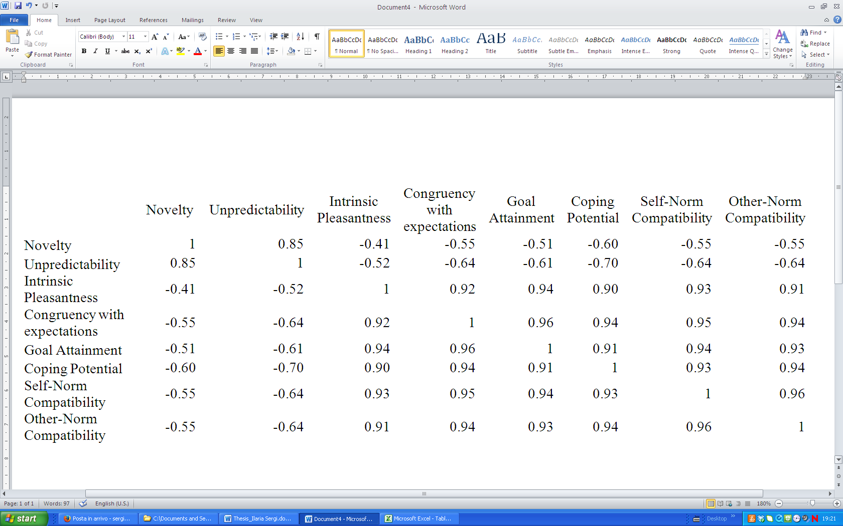Intensity 30%: Correlation Ratings Along Different Appraisal Dimensions*

*Note.* All correlations are significant at the .01 level (two tailed).

Table S10

*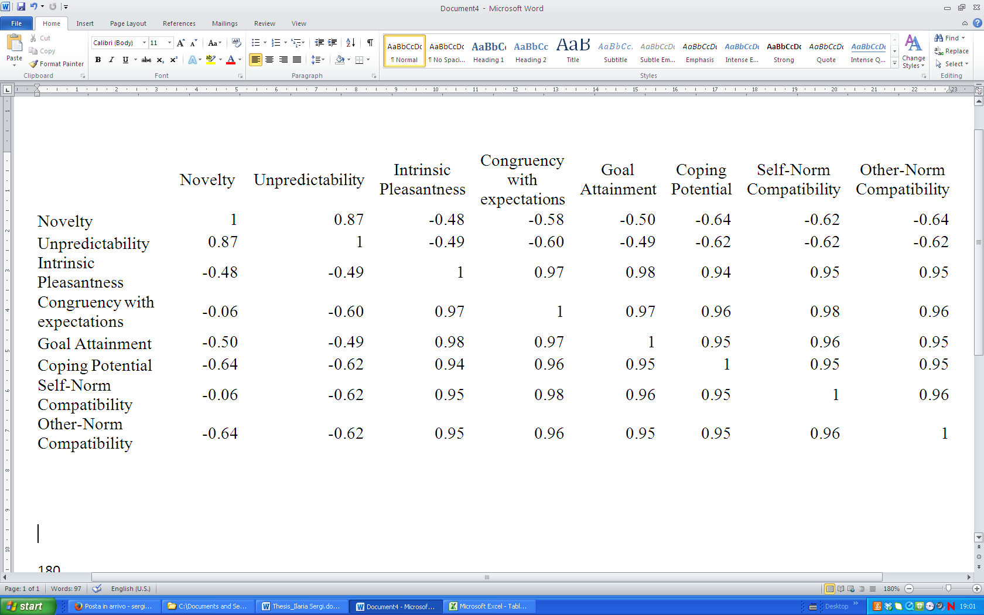Intensity 90%: Correlation Ratings Along Different Appraisal Dimensions*

*Note.* All correlations are significant at the .01 level (two tailed).

Table S11

*Intensity 30%: Significant Associations Between Individual Action Units (AUs) and Appraisal Dimensions Resulting From Planned Comparisons on Standardized Residual Average Ratings*

|  |  |  |  |
| --- | --- | --- | --- |
| AU | Appraisal | *p* | ηp2 |
| AU1 | Goal conduciveness | t | 0.07 |
| **Coping potential** | * | 0.14 |
| AU2 | **Novelty** | * | 0.10 |
| Unpredictability | t | 0.07 |
| Intrinsic pleasantness | * | 0.13 |
| Goal conduciveness | * | 0.11 |
| AU5 | Goal conduciveness | t | 0.00 |
| AU6 | **Coping potential** | t | 0.07 |
| AU10 | **Intrinsic pleasantness** | * | 0.11 |
| AU16 | Novelty | * | 0.11 |
| AU17 | Unpredictability | * | 0.11 |
| **Intrinsic pleasantness** | t | 0.07 |
| **Coping potential** | ** | 0.18 |
| Self-norm compatibility | * | 0.11 |
| Other-norm compatibility | * | 0.13 |
| AU23 | Intrinsic pleasantness | ** | 0.21 |
| **Goal conduciveness** | ** | 0.17 |
| AU24 | Novelty | t | 0.07 |
| Unpredictability | ** | 0.19 |
| **Intrinsic pleasantness** | t | 0.09 |
| Congruency with expectations | t | 0.09 |
| **Coping potential** | ** | 0.17 |
| Self-norm compatibility | t | 0.07 |
| Other-norm compatibility | * | 0.12 |
| AU25 | **Goal conduciveness** | * | 0.11 |
| AU26 | **Novelty** | ** | 0.19 |
| Unpredictability | ** | 0.21 |
| Congruency with expectations | * | 0.10 |
| **Coping potential** | * | 0.12 |
| Self-norm compatibility | ** | 0.21 |
| AU27 | Novelty | ** | 0.21 |
| Unpredictability | *** | 0.26 |
| **Coping potential** | * | 0.15 |
| AU38 | Self-norm compatibility | t | 0.08 |
| AU43 | Novelty | * | 0.10 |
| Self-norm compatibility | t | 0.08 |

*Note*. Boldface: Values matching Component Process Model predictions.

\**p* ≤ .05, \*\**p* ≤ .01, \*\*\**p* ≤ .001, t Trend towards significance.

Table S12

*Intensity 90%: Significant Associations Between Individual Action Units (AUs) and Appraisal Dimensions Resulting From Planned Comparisons on Standardized Residual Average Ratings*

|  |  |  |  |
| --- | --- | --- | --- |
| AU | Appraisal | *p* | ηp2 |
| AU1 | Unpredictability | * | 0.11 |
| **Congruency with expectations** | t | 0.08 |
| **Coping potential** | * | 0.10 |
| AU2 | **Novelty** | ** | 0.16 |
| Unpredictability | *** | 0.25 |
| **Congruency with expectations** | ** | 0.00 |
| Coping potential | ** | 0.16 |
| Self-norm compatibility | t | 0.08 |
| AU5 | **Novelty** | ** | 0.22 |
| Unpredictability | *** | 0.37 |
| **Coping potential** | * | 0.13 |
| Self-norm compatibility | t | 0.07 |
| Other-norm compatibility | * | 0.10 |
| AU9 | **Intrinsic pleasantness** | * | 0.09 |
| AU15 | Unpredictability | t | 0.09 |
| Congruency with expectations | ** | 0.16 |
| Self-norm compatibility | * | 0.12 |
| Other-norm compatibility | * | 0.11 |
| AU16 | Unpredictability | * | 0.09 |
| Other-norm compatibility | t | 0.07 |
| AU17 | Novelty | t | 0.07 |
| AU24 | Novelty | t | 0.09 |
| AU25 | Novelty | * | 0.11 |
| Unpredictability | * | 0.10 |
| AU26 | **Novelty** | *** | 0.23 |
| Unpredictability | ** | 0.23 |
| **Intrinsic pleasantness** | t | 0.07 |
| Goal conduciveness | t | 0.07 |
| **Coping potential** | * | 0.09 |
| Self-norm compatibility | ** | 0.18 |
| AU27 | Novelty | * | 0.15 |
| Intrinsic pleasantness | ** | 0.19 |
| Goal conduciveness | ** | 0.19 |
| **Coping potential** | *** | 0.25 |
| Self-norm compatibility | * | 0.14 |
| Other-norm compatibility | t | 0.08 |
| AU43 | Novelty | t | 0.09 |
| Unpredictability | * | 0.12 |
| Congruency with expectations | ** | 0.15 |
| Self-norm compatibility | *** | 0.30 |
| Other-norm compatibility | * | 0.11 |

*Note*. Boldface: Values matching Component Process Model predictions.

\**p* ≤ .05, \*\**p* ≤ .01, \*\*\**p* ≤ .001, t Trend towards significance.

Table S13

*Intensity 30%: Linear Regression Analysis: Beta Coefficients and Significance Values Associated With Individual Action Unit (AU) Predictors (Residualized Averages)*

|  |  |  |  |
| --- | --- | --- | --- |
| Appraisal | AU combination | Beta | Significance |
| Novelty | AU27 | 0.50 | *** |
| **AU26** | 0.57 | *** |
| AU43 | -0.48 | *** |
| AU25 | 0.40 | *** |
| **AU2** | 0.27 | ** |
| AU23 | -0.21 | * |
| Unpredictability | AU27 | 0.50 | *** |
| AU26 | 0.45 | *** |
| AU24 | -0.38 | *** |
| AU20 | -0.28 | ** |
| AU43 | -0.26 | ** |
| Intrinsic pleasantness | AU23 | -0.42 | ** |
| AU2 | 0.28 | * |
| **AU10** | -0.28 | * |
| Congruency with expectations | AU26 | -0.32 | * |
| Goal conduciveness | **AU23** | 0.38 | ** |
| AU2 | -0.30 | * |
| Coping potential | **AU17** | 0.23 | . |
| **AU27** | -0.42 | ** |
| **AU1** | -0.32 | * |
| **AU26** | -0.28 | * |
| Self-norm compatibility | AU26 | -0.46 | ** |
| AU38 | 0.30 | * |
| Other-norm compatibility | AU17 | 0.36 | * |

*Note*. Boldface: Values matching Component Process Model predictions.

\**p* ≤ .05, \*\**p* ≤ .01, \*\*\**p* ≤ .001.

Table S14

*Intensity 90% to Intensity 30%: Linear Regression Analysis: Beta Coefficients and Significance Values Associated With Individual Action Unit (AU) Predictors (Residualized Averages)*

|  |  |  |  |
| --- | --- | --- | --- |
| Appraisal | AU combination | Beta | Significance |
| Novelty | **AU26** | 0.51 | *** |
| AU27 | 0.47 | *** |
| **AU5** | 0.25 | * |
| AU10 | 0.29 | ** |
| **AU2** | 0.29 | ** |
| AU43 | -0.19 | * |
| Unpredictability | AU5 | 0.43 | *** |
| AU26 | 0.44 | *** |
| AU43 | -0.37 | *** |
| AU27 | 0.26 | ** |
| AU1 | 0.28 | ** |
| Intrinsic pleasantness | AU27 | 0.45 | ** |
| **AU25** | 0.29 | * |
| Congruency with expectations | **AU2** | -0.39 | ** |
| AU15 | 0.41 | ** |
| AU12 | 0.27 | * |
| Goal conduciveness | AU27 | -0.43 | ** |
| Coping potential | **AU27** | -0.55 | *** |
| AU2 | -0.40 | *** |
| **AU26** | -0.33 | ** |
| Self-norm compatibility | AU43 | 0.55 | *** |
| AU27 | -0.36 | ** |
| AU26 | -0.27 | * |
| Other-norm compatibility | AU26 | -0.49 | *** |
| AU43 | 0.35 | ** |
| AU27 | -0.31 | * |

*Note*. Boldface: Values matching CPM predictions.

\**p* ≤ .05,\*\**p* ≤ .01, \*\*\**p* ≤ .001.

*Figure S1.* Intensity 30%: Difference between original mean ratings (dark grey line) and standardized residual average scores (light grey line) for all appraisal categories. AU = action unit.

*Figure S2.* Intensity 60%: Difference between original mean ratings (dark grey line) and standardized residual average scores (light grey line) for all appraisal categories. AU = action unit.

*Figure S3.* Intensity 90%: Difference between original mean ratings (dark grey line) and standardized residual average scores (light grey line) for all appraisal categories. AU = action unit.