IGI Global Scientific Publishing
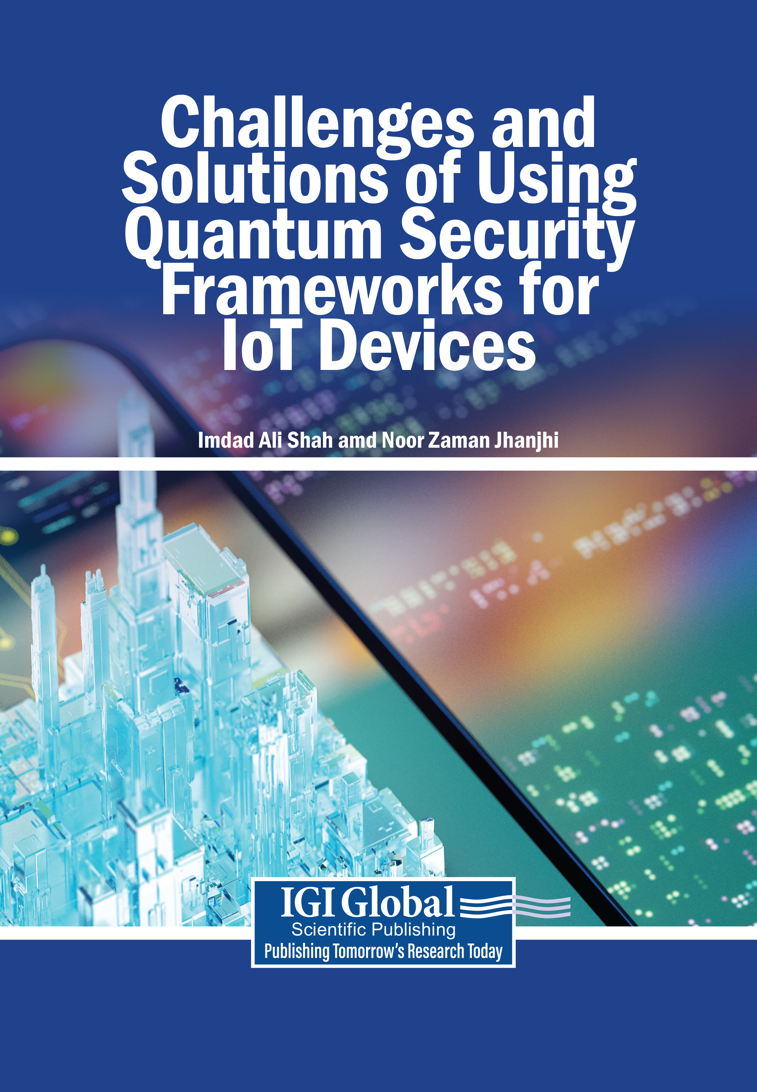
The rapid advancement of quantum computing is reshaping the cybersecurity landscape, introducing both powerful opportunities and significant risks as traditional encryption methods become increasingly vulnerable to quantum-enabled attacks. This shift poses a critical challenge for the Internet of Things (IoT), where vast networks of interconnected devices rely on lightweight and often fragile security frameworks. Widely deployed across sectors such as healthcare, finance, smart cities, and industrial systems, IoT devices handle sensitive data but are constrained by limited processing power and storage capacity. As a result, the emergence of quantum threats highlights the urgent need for developing and implementing quantum-resistant security solutions tailored to IoT environments.
Challenges and Solutions of Using Quantum Security Frameworks for IoT Devices explore the challenges and solutions associated with implementing quantum security frameworks for IoT devices. As quantum computing continues to advance, it not only enhances computational capabilities but also threatens the foundations of traditional cryptographic systems on which IoT devices heavily rely. In response, this book examines the integration of quantum-resistant cryptographic approaches alongside adaptive security mechanisms tailored to resource-constrained devices. Covering topics such as artificial intelligence, network overload, and swarm robotics communications, this book is an excellent academic resource for graduate and doctoral students, cybersecurity professionals, IoT developers and engineers, quantum computing researchers, technology executives, and more.
Challenges and Solutions of Using Quantum Security Frameworks for IoT Devices:
Imdad Ali Shah, (Iqra University, Pakistan)
Noor Zaman Jhanjhi, (Taylor’s University, Malaysia)

Description:
- Artificial Intelligence (AI)
- Blockchain
- Deepfake Detection
- Distributed Denial-of-Service (DDoS) Attacks
- Flash Events
- Internet of Things (IoT)

- Metaverse Communications
- Network Overload
- Privacy-Preserving Ecosystems
- Quantum Driven Finance
- Quantum Security Frameworks
- Swarm Robotics Communication

ISBN: 9798337338576 Pages: 465 Copyright: 2026 Release Date: 05/08/2026
Hardcover: $255 Softcover: $215 E-Book: $245 Hardcover + E-Book: $255
Topics Covered:
Order Information
Phone: 717-533-8845 x100
Toll Free: 1-866-342-6657
Fax: 717-533-8661 or 717-533-7115
www.igi-global.com
Address: 701 East Chocolate Avenue, Hershey PA, 17033, USA

Subject: Security and Forensics
Readership Level: Advanced-Academic Level (Research Recommended)
Classification: Edited Research
Research Suitable For: Advanced Undergraduate Students; Graduate Students; Researchers; Academicians; Professionals; Practitioners


